**Region Based Brain Computer Interface for A Home Control**

**Application**

Eda AKMAN AYDIN, Ömer Faruk BAY and İnan GÜLER

**Overview –** Smart home control is an improvement in the living conditions of any disabled person. This paper presents a region based paradigm to control the home by using P300 Visually Evoked Potentials where the stimulus is the control to be made to the home. This requires initial training which is done using the oddball method. A Linear Discriminant Classifier is used to classify the signals into the appropriate class. The region based paradigm is an advancement over Row-Column based and Single Character Based Paradigm. These paradigms use matrix as stimulus pattern where each element of the matrix is intensified. The problem with such paradigms is that adjacency error may occur which is the intensification of adjacent rows or columns leading to generation of p300 signal. The region based paradigm uses regions of characters or images which identify a particular control, separated from each other. This decreases the adjacency error as well as the dimensions of the matrix increasing with increase in gadgets to control.

**Procedure-** The region based paradigm divides the controls into two regions. Each region contains 7 symbols each of which leads to the next region. The characters in the first level/region are intensified one by one. When the subject selects the appropriate region the control transfers to the next region/level which give even more options about the selection made at the first level. An illustration of the above procedure is shown in the below figure.

 

**Experiment** – Five healthy male subjects were selected and EEG was recorded using a 16 active electrodes cap. Prior to training session each of the regions was intensified randomly and the subjects were asked to count the number of regions. During traning the subjects were asked to do 10 different tasks which would require 20 selections, 10 at each of the levels. After training session, the subjects were asked to make 20 selection in the testing phase. Their brain activities were recorded throughout the training and testing phase. Each region was flashed 15 times in each level. The lit and dark time for each region was 150ms each and there was a 2 second gap to go from region 1 to region 2. Hence the total time required to make a selection in 1 level was (7* 15 * 300) 31.5. The selection at the other level was also 31.5 and there is a 2 second delay in switching from level 1 and 2, the entire task of selecting a particular control would take 65 seconds.

**Data pre-processing and classification** – After the signals were recorder, they were divided into 1 second epoch for each stimulus onset. After baseline correction, signal was filtered by a lowpass filter with the cut off frequency 5Hz. Then, the signals were down-sampled to 30Hz. The downsampled data from 16 channels were reconstructed into a feature vectors. Classification was performed by using Linear Discriminant Analysis (LDA) for each participant individually.

**Results** – The mean accuracy of all subjects(5) at 5 flashes was around 95% and the accuracy increased as the number of flashes increased.

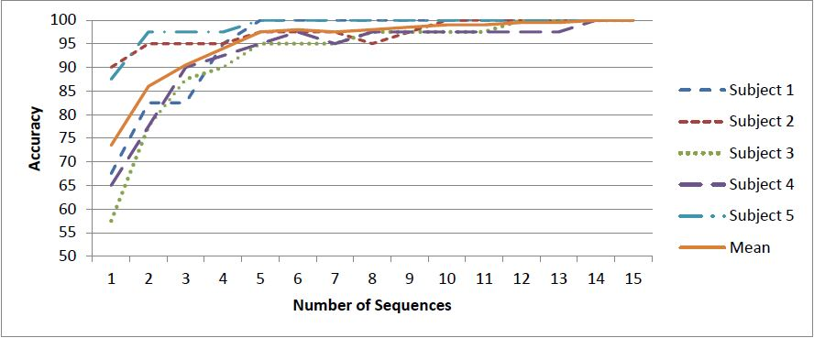

Figure 2 Region prediction accuracy rates across all subjects versus numbers of flashes

**Conclusion –** This papers aims at using a region based paradigm to solve some problems with earlier matrix based paradigms to control a smart home environment. The superior accuracy indicates the model can be deloyed in real time to control the appliances. The drawback however is that due to selection at 2 levels, the selection duration increases with the number the control options.